Lab 11

Configuring DirectAccess

This lab contains the following exercises and activities:

|  |  |
| --- | --- |
| Exercise 11.1 | Implementing Client Configuration |
| Exercise 11.2 | Implementing DirectAccess Server |
| Exercise 11.3 | Implementing the Infrastructure Servers |
| Exercise 11.4 | Implementing the Application Servers |
| Lab Challenge | Configuring Certificates for DirectAccess |

BEFORE YOU BEGIN

The lab environment consists of student workstations connected to a local area network, along with a server that functions as the domain controller for a domain called *contoso.com*. The computers required for this lab are listed in Table 11-1.

Table 11-1

Computers Required for Lab 11

|  |  |  |
| --- | --- | --- |
| Computer | Operating System | Computer Name |
| Server (VM 1) | Windows Server 2012 | RWDC01 |
| Server (VM 2) | Windows Server 2012 | Server01 |

In addition to the computers, you also require the software listed in Table 11-2 to complete Lab 11.

Table 11-2

Software Required for Lab 11

|  |  |
| --- | --- |
| Software | Location |
| Lab 11 student worksheet | Lab11_worksheet.rtf (provided by instructor) |

Working with Lab Worksheets

Each lab in this manual requires that you answer questions, take screen shots, and perform other activities that you will document in a worksheet named for the lab, such as Lab11_worksheet.rtf. You will find these worksheets on the book companion site. It is recommended that you use a USB flash drive to store your worksheets, so you can submit them to your instructor for review. As you perform the exercises in each lab, open the appropriate worksheet file using WordPad, fill in the required information, and save the file to your flash drive.

After completing this lab, you will be able to:

* Configure DirectAccess
* Prepare for DirectAccess Deployment
* Configure certificates for DirectAccess

Estimated lab time: 50 minutes

|  |  |
| --- | --- |
| Exercise 11.1 | Implementing Client Configuration |
| Overview | To implement DirectAccess, the installation and configuration is divided into four steps. During this exercise, you perform Step 1 - Client Configuration. |
| Completion time | 10 minutes |

**Mindset Question: During this lab, you configure the servers to support DirectAccess. What are the minimum requirements for the DirectAccess server?**

**1.** Log in to Server01 as the **Contoso\Administrator** user account. The Server Manager console appears.

**2.** On Server Manager, click Tools > Remote Access Management. The Remote Access Management console opens as shown in Figure 11-1.

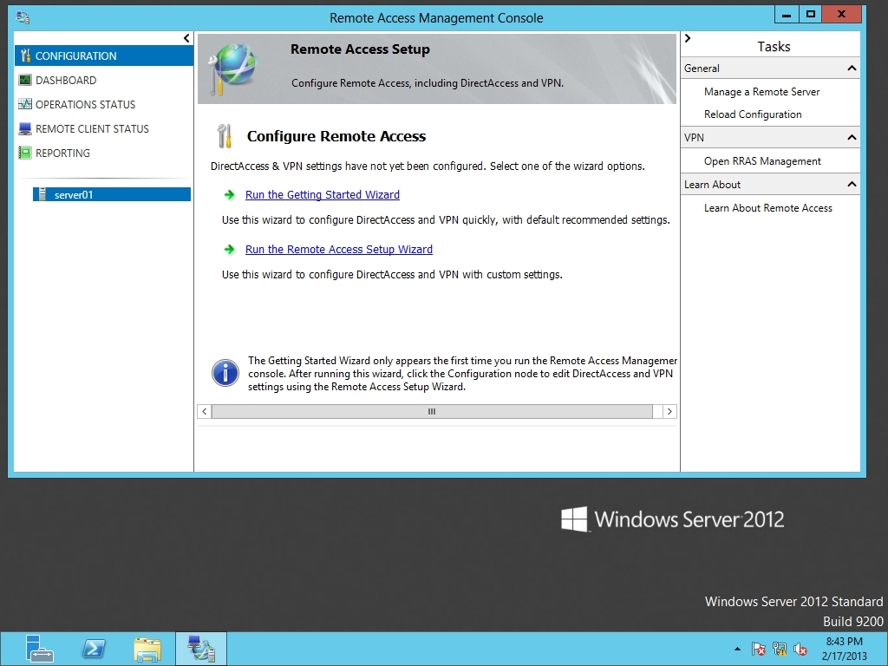

Figure 11-1

Opening the Remote Access Management console

**3.** Click the Run the Remote Access Setup Wizard link.

**4.** When the Configure Remote Access Wizard starts, click Deploy DirectAccess only. The Remote Access Setup console opens as shown in Figure 11-2.

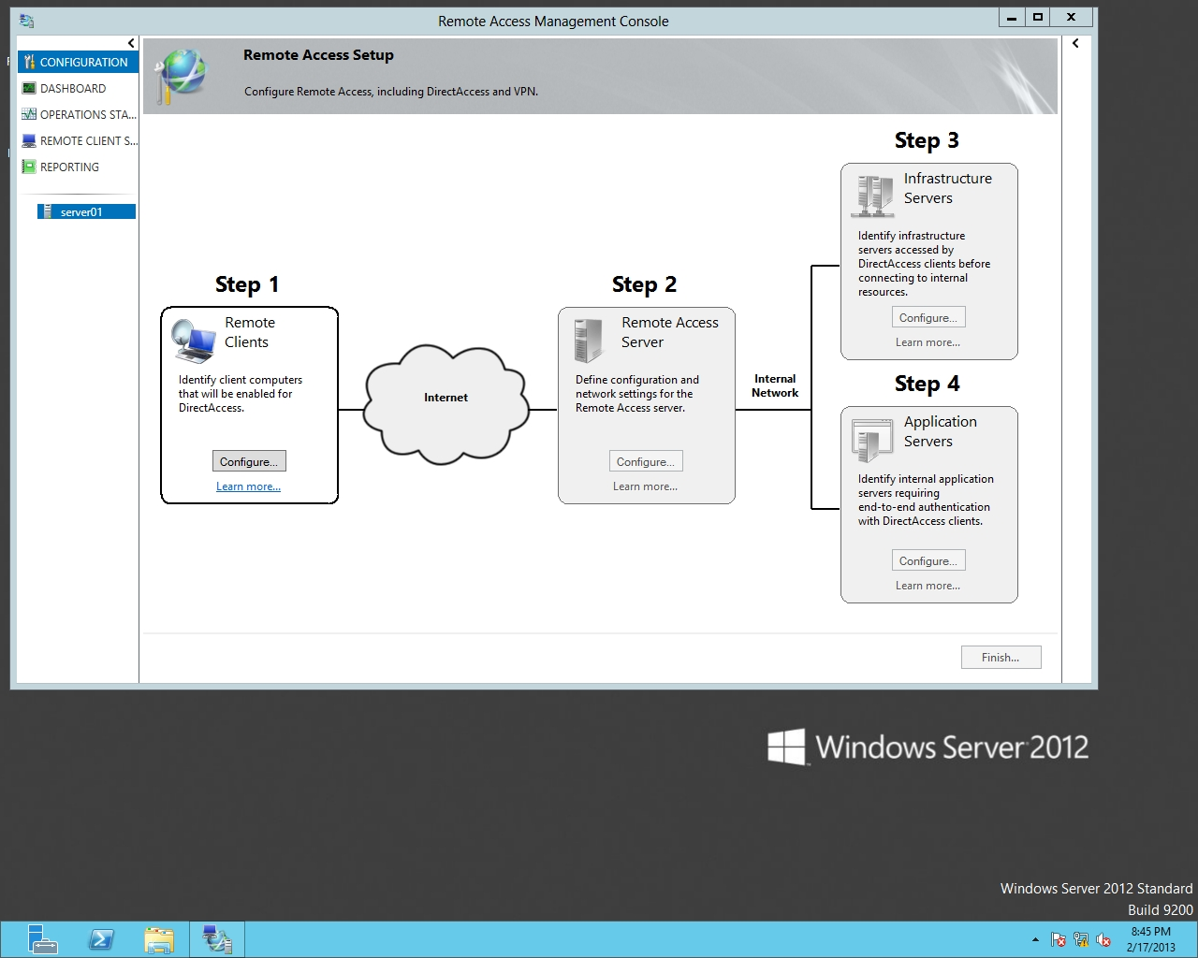

Figure 11-2

Using the Remote Access Setup to configure DirectAccess

**5.** Under Step 1, Remote Clients, click Configure. The DirectAccess Client Setup Wizard opens.

**6.** On the Deployment Scenario page, select *Deploy full DirectAccess for client access and remote management*. Click Next.

**7.** On the Select Groups page, select Add. Type **Domain Computers** in the *Enter the object names to select* text box and and click OK. Click Next.

**8.** On the Network Connectivity Assistant page (as shown in Figure 11-3), double-click a blank resource space. When the Configure Corporate Resources for NCA dialog box opens, change the HTTP to PING and type **RWDC01.CONTOSO.COM** in the text box. Click Add.

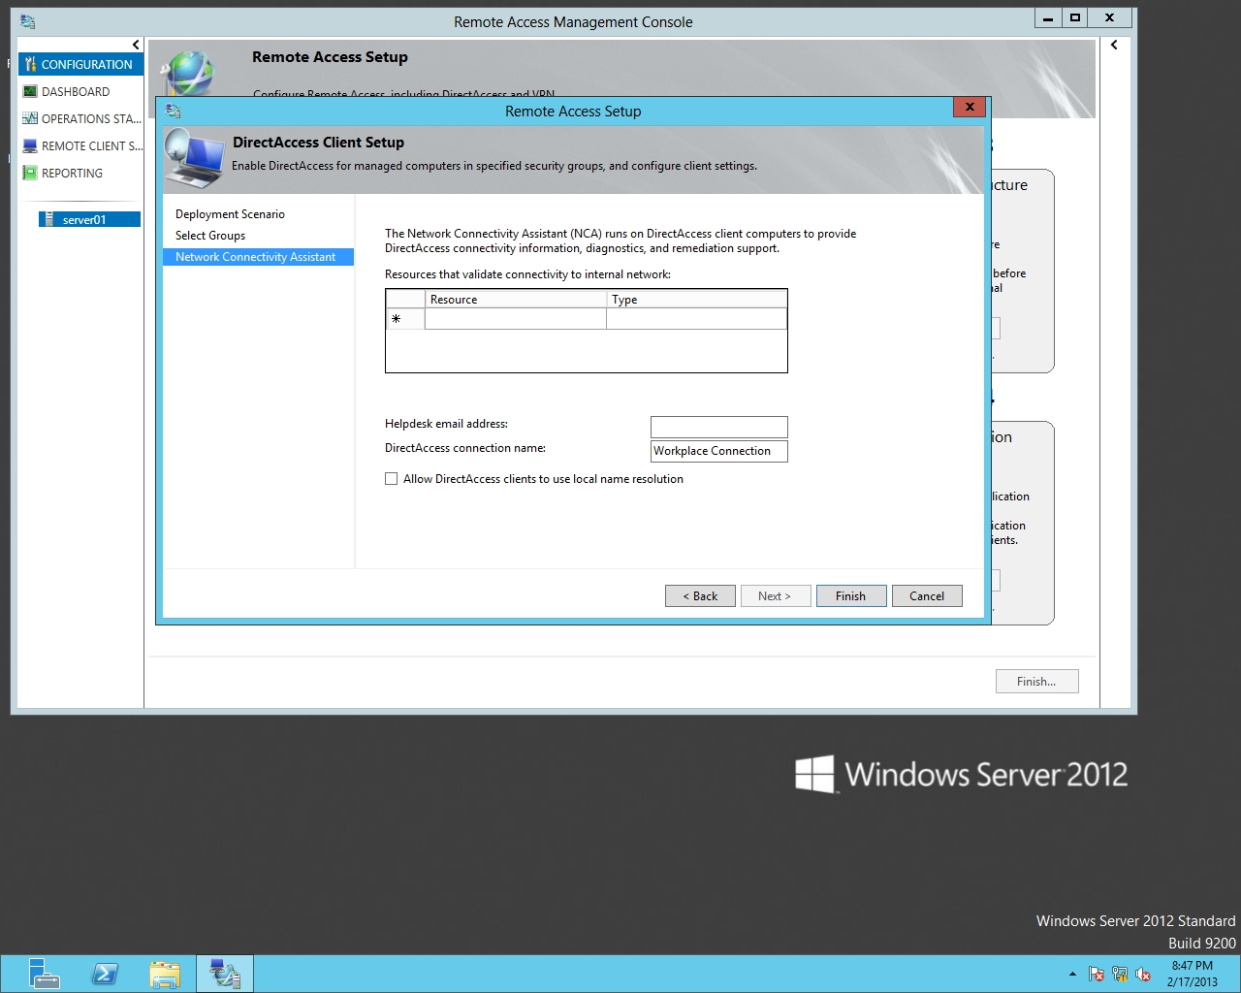

Figure 11-3

Configure the Network Connectivity Assistant

|  |  |
| --- | --- |
| Question 1 | What tool is included with Windows 8 that will help you connect to the DirectAccess server when you have problems and can be used to perform diagnostics for client access to Direct Access? |

**9.** Back on the Network Connectivity Assistant page, click Finish.

**10.** Keep Remote Access Management console open for the next exercise.

End of exercise. You can leave the windows open for the next exercise.

|  |  |
| --- | --- |
| Exercise 11.2 | Implementing DirectAccess Server |
| Overview | During this exercise, you configure DirectAccess configuration Step 2 - Configuring the Remote Access Server. |
| Completion time | 10 minutes |

**Mindset Question: During this lab, you configure the remote access server. Which component or components will you configure during this step?**

**1.** On Server01, using Remote Access Management console, under Step 2, Remote Access Server, click Configure. The Remote Access Server Setup Wizard starts.

**2.** On the Network Topology page (as shown in Figure 11-4), click *Behind an edge device (with two network adapters)*. Then type **server01.contoso.com** in the text box. Click Next.

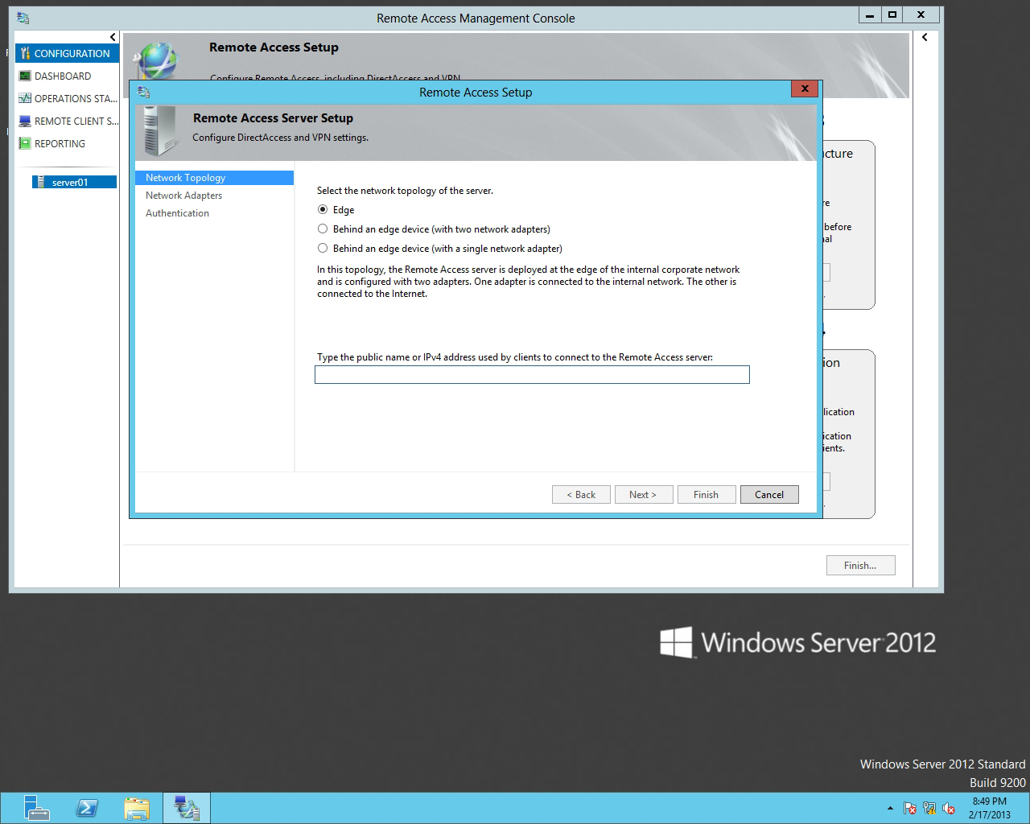

Figure 11-4

Selecting the topology

**3.** On the Network Adapters page, select External for the Adapter connected to the external network and select Internal for the Adapter connected to the internal network.

**4.** Click to select the *Use a self-signed certificate created automatically by DirectAccess*. Click Next.

**5.** On the Authentication page, with Active Directory credentials (username/password) already selected, click Finish.

|  |  |
| --- | --- |
| Question 2 | What type of user authentication is selected by default? |

**6.** Keep Remote Access Management console open for the next exercise.

End of exercise. You can leave the windows open for the next exercise.

|  |  |
| --- | --- |
| Exercise 11.3 | Implementing the Infrastructure Servers |
| Overview | During this exercise, you perform Step 3, where you specify the infrastructure servers that are necessary for DirectAccess to function properly. |
| Completion time | 10 minutes |

**Mindset Question: When configuring Direct Access, what do you configure during Step 3?**

**1.** On Server01, continuing with the Remote Access Setup Configuration page, under Step 3, Infrastructure Server, click Configure. The Infrastructure Server Setup Wizard starts.

**2.** On the Network Location Server page, click *The network location server is deployed on the Remote Access server*. Click to select the *Use a self-signed certificate*.

**3.** Take a screen shot of the DNS Manager window by pressing Alt+Prt Scr and then paste it into your Lab11_worksheet file in the page provided by pressing Ctrl+V.

**4.** Click Next.

**5.** On the DNS page, click Next.

**6.** On the DNS Suffix Search List page, click Next.

**7.** On the Management page, double-click the first line of the Management Servers box to open the Add a Management Server dialog box.

|  |  |
| --- | --- |
| Question 3 | Which management servers would you include? |

**8.** In the Computer name text box, type **rwdc01.contoso.com** and click OK.

**9.** Click Finish.

**10.** Keep Remote Access Management console open for the next exercise.

End of exercise. You can leave the windows open for the next exercise.

|  |  |
| --- | --- |
| Exercise 11.4 | Implementing the Application Servers |
| Overview | Lastly, during Step 4, you need to configure any application servers and apply all the changes that you have configured for Steps 1 through 4. |
| Completion time | 5 minutes |

**Mindset Question: When configuring Direct Access, what do you configure during Step 4?**

**1.** On Server01, continuing with the Remote Access Setup Configuration page, under Step 4, Application Servers, click Configure. The DirectAccess Application Server Setup Wizard starts.

**2.** On the DirectAccess Application Server Setup page, click Finish, accepting the default option selected – Do not extend authentication.

**3.** At the bottom of the Remote Access Management console, click Finish to apply all the changes for Steps 1 through 4.

**4.** Take a screen shot of the Remote Access Management Console window by pressing Alt+Prt Scr and then paste it into your Lab011_worksheet file in the page provided by pressing Ctrl+V.

**5.** When the Remote Access Review dialog box opens, click Apply.

**6.** When the settings have been applied, click Close. Close the Remote Access Management Console.

Lab REview Questions

|  |  |
| --- | --- |
| **Completion time** | **5 minutes** |

**1.** In Exercise 11.1, what tool is used to configure DirectAccess?

**2.** In Exercise 11.2, in which step did you specify the certificate authority?

**3.** In Exercise 11.3, what is the function of the Network Location Server?

|  |  |
| --- | --- |
| Lab Challenge | Configuring Certificates for DirectAccess |
| Overview | To complete this challenge, you will demonstrate how to configure certificates for DirectoAccess by writing the high-level steps to complete the tasks described in the scenerio. |
| Completion time | 10 minutes |

For DirectAccess to function, you must install and configure a Certificate Authority so that it can hand out digital certificates for the clients. You also need to install and configure digital certificates for the IP-HTTPS listener. Explain in general steps what is needed to configure the certificate requirements needed for DirectAccess.

End of lab. You can log off or start a different lab. If you want to restart this lab, you’ll need to click the End Lab button in order for the lab to be reset.